October 12, 2026
Neo Mei Meikubushi
gITHUB LINK
https://github.com/MeiKubushi/MunicipalIssueReporting
aapd7112 assignment 2/task 2
st10538212
Screenshots
Home landing form page
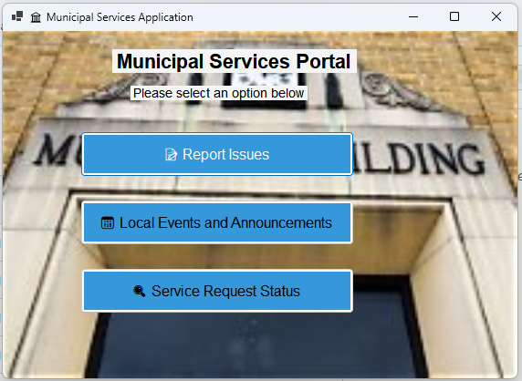
Report Issues Page
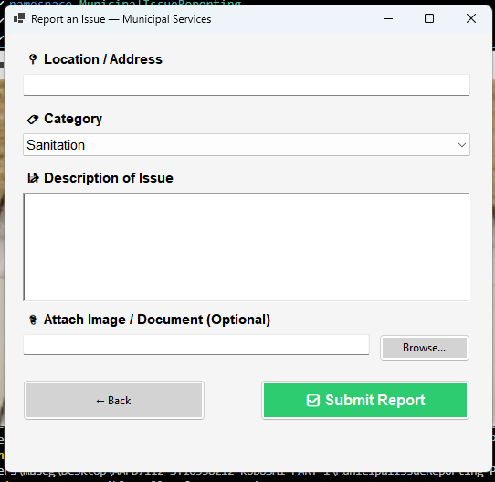

One issue reported
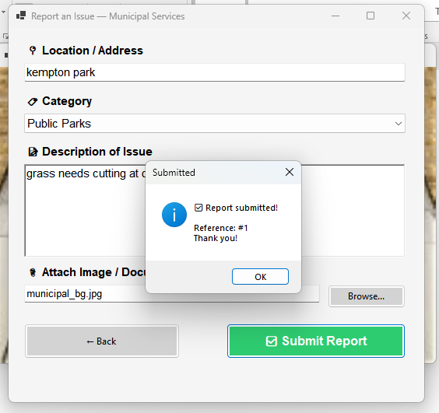

Service Requests it shows the reported issue, user can log more than 1 issue and use reference number to check back, users can attach images if they wish.

Service request Status
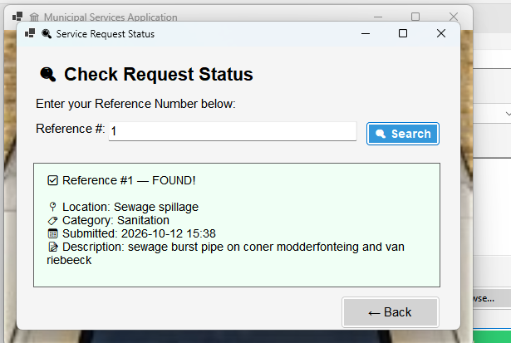
Local and Upcoming events ,5 events currently showing at a time
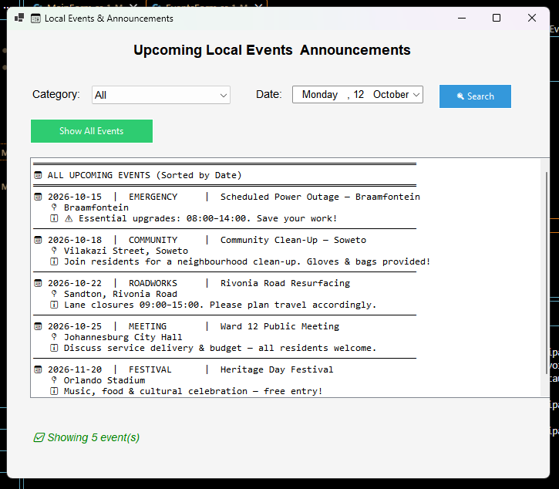

When the date is changed to search for a particular day
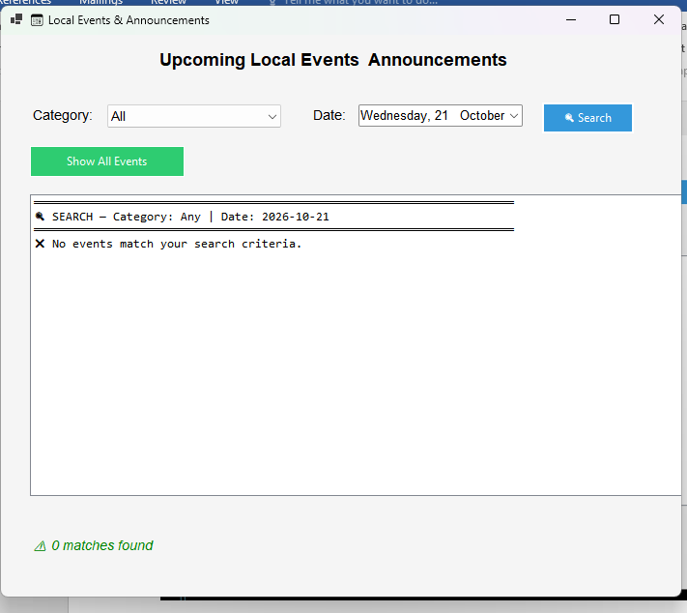

Search Button has functionality , you cant search for an event which was not loaded
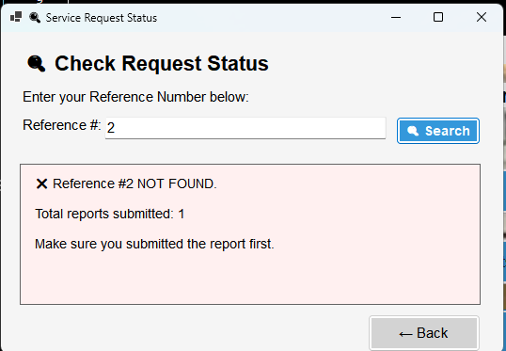

Sample Events into Sorted Dictionary
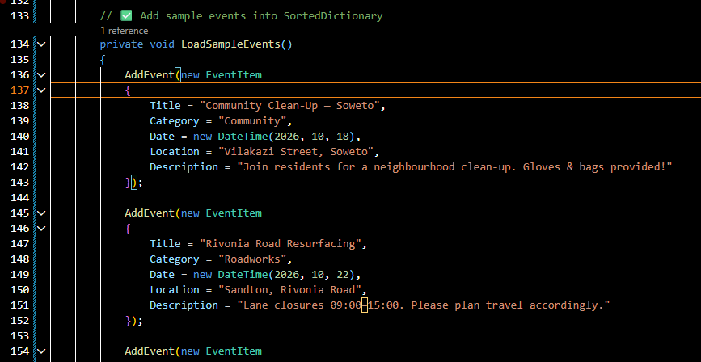
Search by Category and date using foreach loop
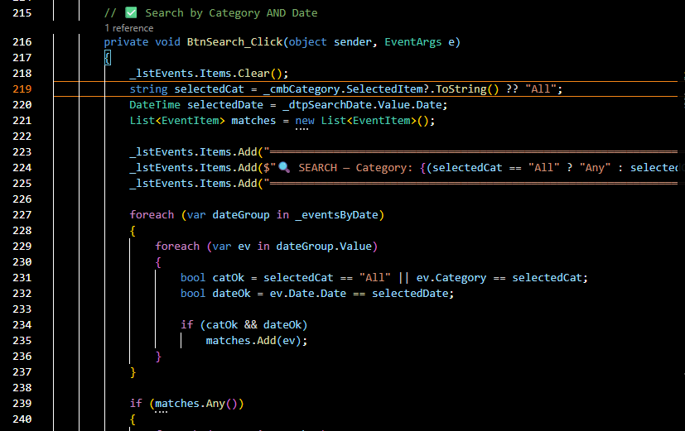
Back Button Added
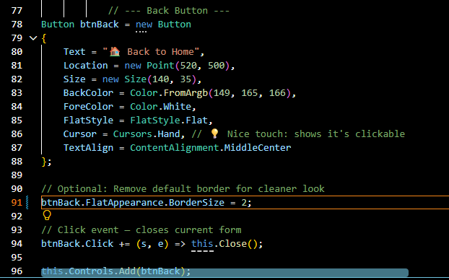

Search Controls
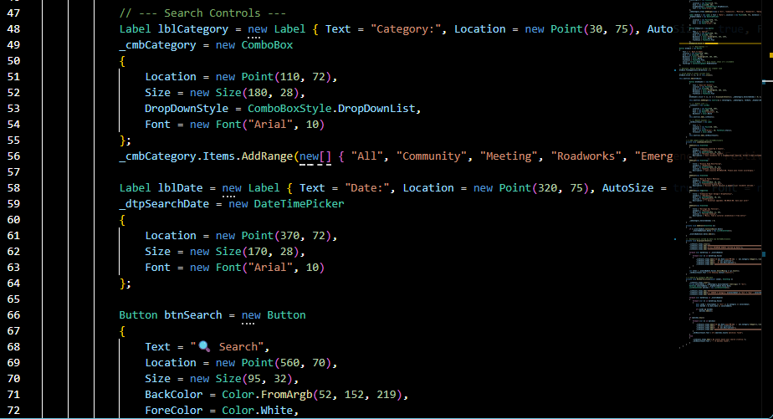
Assignment updates committed
